Dear Steeple Run Families,
How time flies while we are having fun! In keeping with the theme, “I believe everyone has a Super Hero inside of them waiting to be discovered,” Steeple Run staff is honoring one another as they exhibit their super hero powers. Teachers have also been acknowledging the super hero inside of their students. A couple of special projects were completed in third grade and kindergarten.
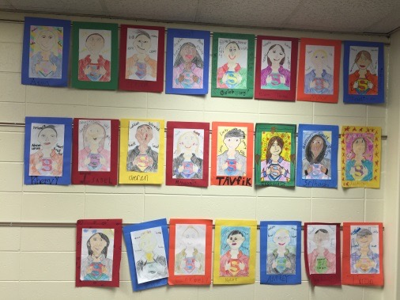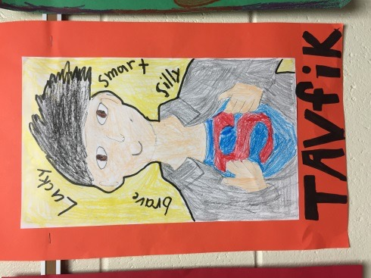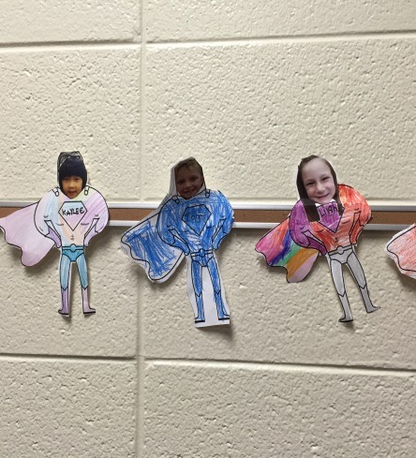
In the month of October we were visited by a famous author Todd Parr. The link below is from his website. Enjoy!
http://www.toddparr.com/imgs/toddtv/video/BeWhoYouAre.m4v

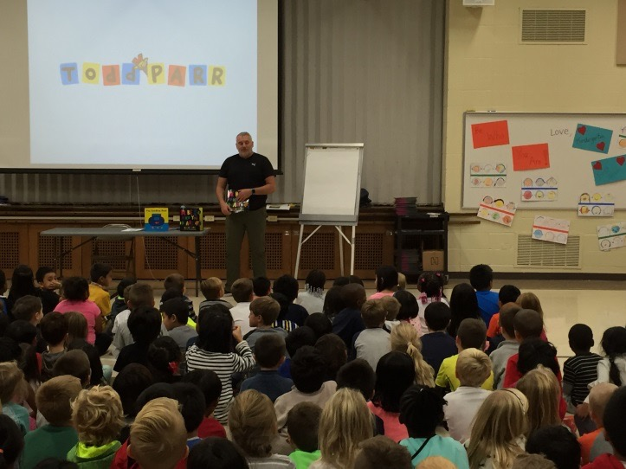
He joined the kindergarten and first grade students and shared a couple of his books including his newly released book, Be Who You Are! The joyful laughter was contagious!

We also enjoyed two exciting days with the fifth grade students at Camp Manitoqua for outdoor education. A great time was had by all. Click on the link below to view some exciting photos!
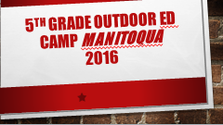
https://drive.google.com/file/d/0B0TtCskQVQgTeGdheW9TMHlPUnc/view?usp=sharing
October 31, 2016 was celebrated with fall parties and a parade. What a beautiful day to celebrate!
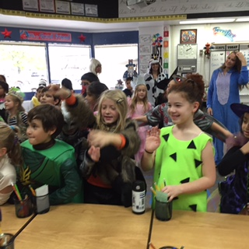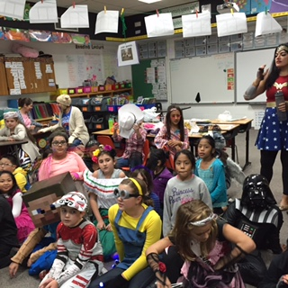
Looking forward to continued learning and more fun this year!
Mrs. Doyle, Mrs. VanNess & Greg too (a.k.a. Mr. Mitchell)
